**Department Of Computer Science And Engineering**

**19CS30E - ADVANCED JAVA PROGRAMMING**

**ONLINE E-PHARMACY SYSTEM IN JSP**

**Project Report**



**SUBMITTED BY**

**KESAVAN S - 2112065**

**MITHUNKUMAR C - 2112100**

**MANOJ KUMAR K - 2112069**

| **TABLE OF CONTENTS**   1. **Abstract** 2. **Introduction**   **2.1 Project Statement**  **2.2 Project Description**  **2.3 Technology Stack**   1. **Modules**   **3.1 Login Page for Vendor login, Customer login**  **3.2 Register Page**  **3.3 Customer Homepage**  **3.4 Vendor Homepage**  **3.5 Buy Page**  **3.5 Vendor Restock Page**  **3.7 Home page**  **3.8 Products**  **3.9 Add product**  **3.10 Purchase Medicine**  **3.11 View Order**   1. **System Requirements**   **4.1 Hardware requirements**  **4.2 Software requirements**   1. **Tools and Technologies used**   **5.1 Introduction to to NetBeans IDE:**  **5.2 Introduction to CSS(Cascading Style Sheet)**  **5.3 Introduction to HTML(Hyper Text Markup Language)**  **5.4 JSP Description**  **5.5 What is TOMCAT?**   1. **Tables**   **6.1 Customer**  **6.2 Seller**  **6.3 Orders**  **6.4 Inventory**  **6.5 Products**     1. **Screenshots** 2. **Source Code** 3. **Conclusion** 4. **References** |
| --- |

# 

# **1. ABSTRACT**

The "Online E-Pharmacy System" has been developed to override the problems prevailing in the practicing manual system. This software is supported to eliminate and in some cases reduce the hardships faced by this existing system. Moreover, this system is designed for the particular need of the company to carry out operations in a smooth and effective manner.

The application is reduced as much as possible to avoid errors while entering the data. It also provides an error message while entering invalid data. No formal knowledge is needed for the user to use this system. Thus by this all it proves it is user-friendly. Online Pharmacy System, as described above, can lead to error-free, secure, reliable, and fast management system. It can assist the user to concentrate on their other activities rather than concentrate on the record keeping. Thus it will help organizations in better utilization of resources.

Every organization, whether big or small, has challenges to overcome and manage the information of Medicine Company, Customer, Medicine Stock, Payment, Order. Every Online Medical Store has different Customer needs, therefore we design exclusive employee management systems that are adapted to your managerial requirements. This is designed to assist in strategic planning, and will help you ensure that your organization is equipped with the right level of information and details for your future goals. Also, for those busy executive who are always on the go, our systems come with remote access features, which will allow you to manage your workforce anytime, at all times. These systems will ultimately allow you to better manage resources.

**2.** **INTRODUCTION**

**Project Statement :**

The Online E-Pharmacy System project aims to develop a web-based platform using Java Server Pages (JSP) and NetBeans as the primary technology stack. This system will provide a convenient and secure way for users to purchase pharmaceutical products online. It will enable users to browse a catalog of medications, place orders, and receive a generated report.

**Project Description:**

In the current scenario, accessing pharmaceutical products often involves visiting physical pharmacies, which can be time-consuming and inconvenient, especially for individuals with mobility issues or in emergencies. An online e-pharmacy system can address these challenges and provide the following key features:

**User Registration and Authentication:**

Users should be able to create accounts, log in, and manage their profiles securely.

Authentication and authorization mechanisms should be in place to protect user data and ensure secure transactions.

**Vendor Registration and Authentication:**

Vendors should be able to create accounts, log in, add products, and restock products.

Authentication and authorization mechanisms should be in place to protect vendor data and ensure secure transactions.

**Product Catalog:**

The system should maintain a comprehensive catalog of pharmaceutical products.

Products should be categorized, with detailed information available for each item, including price, manufacturing date, expiry date, and manufacturer.

**Shopping Cart:**

Users should be able to add products to a shopping cart and make changes before proceeding to checkout.

**Inventory Management:**

Real-time inventory management to prevent overselling and ensure product availability.

Notifications for out-of-stock items or low stock levels.

**Technology Stack :**

1. **HTML**: Page layout has been designed in HTML
2. **CSS**: CSS has been used for all the design part
3. **JavaScript**: All the validation task and animations has been developed by JavaScript
4. **JSP**: All the front-end logic has been written in JSP
5. **Java**: All the business logic has been written in Java
6. **MySQL**: MySQL database has been used as a database for the project
7. **Tomcat**: The project will be run over the Tomcat server

**3. MODULES**

The modules present in the project include the following

* Home page
* Login Page - Vendor login, Customer login
* Register Page
* Customer Homepage
* Vendor Homepage
* Buy Page
* Vendor Restock Page
* Add product
* View Order

**1. Home Page:**

This is the main landing page of the application. It may contain general information about the e-pharmacy system, announcements, and links to customer and vendor login pages.

**2. Login Page:**

**Vendor Login:** This page allows vendors to log in to their accounts by providing their credentials (username and password).

**Customer Login:** This page enables customers to log in with their own set of credentials (username and password).

**3. Register Page:**

This page allows new users (both vendors and customers) to create accounts by providing required registration details, including username, password, contact information, and possibly additional details.

**4. Customer Homepage:**

Upon successful login, customers are directed to their homepage. This page may display a personalized welcome message, order history, and links to various features like the Buy Page and View Order.

**5. Vendor Homepage:**

After successful vendor login, vendors are redirected to their homepage. This page may display information related to their store, inventory status, and links to features like the Vendor Restock Page and Add Product.

**6. Buy Page:**

Customers can browse and search for pharmaceutical products on this page. They can view product details, add items to their shopping cart, and proceed to purchase medicines.

**7. Vendor Restock Page:**

Vendors can use this page to manage their inventory. They can view current stock levels, update stock quantities, and add new products to their inventory.

**8. Add Product:**

Vendors can use this page to add new products to their store's inventory. They should be able to provide product details such as name, description, price, dosage, manufacturer, and images.

**9. View Order:**

Customers can use this page to track their orders. It displays order history, current order status, and details of previous transactions

**4. SYSTEM REQUIREMENTS**

**1. Hardware Requirements:**

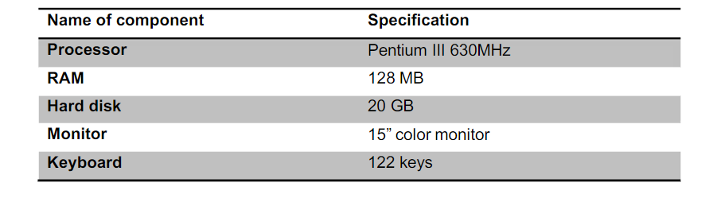

**2. Software Requirements:**

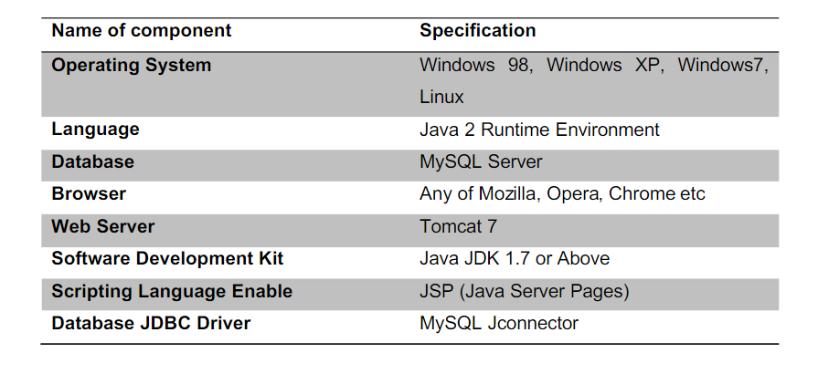

**5.TOOLS AND TECHNOLOGIES USED**

**Introduction to NetBeans IDE:**

NetBeans IDE is a free, open source, integrated development environment (IDE) that enables you to develop desktop, mobile and web applications. The IDE supports application development in various languages, including Java, HTML5, PHP and C++. The IDE provides integrated support for the complete development cycle, from project creation through debugging, profiling and deployment. The IDE runs on Windows, Linux, Mac OS X, and other UNIX-based systems.

## **Introduction to CSS(Cascading Style Sheet):**

CSS is a style sheet language used for describing the look and formatting of a document written in a markup language While most often used to style web pages and interfaces written in HTML and XHTML, the language can be applied to any kind of XML document. One of the favored features is its ability to allow the sorting of document content written in markup languages (like HTML) from document presentation written in CSS. Here are more advantages of CSS in website design:

1. Search Engine Optimization And Appearance

2. Maintainability and Browser Compatibility

## **Introduction to HTML(Hyper Text Markup Language):**

HTML refers to the Hypertext Markup Language. HTML is used to create webpages. It uses many tags to make a webpage. So it is a tag based language. The tags of HTML are surrounded by angular bracket. It can use wide ranges of colors, objects and layouts. Very useful for beginners in web designing field.

**Advantages of HTML**

1. First advantage it is widely used.

2. Every browser supports HTML language.

3. Easy to learn and use.

4. It is by default in every window so you don't need to purchase extra software.

## **JSP Description:**

JavaServer Pages (JSP) is a technology for developing Webpages that supports dynamic content. This helps developers insert java code in HTML pages by making use of special JSP tags, most of which start with <% and end with %>.

A JavaServer Pages component is a type of Java servlet that is designed to fulfill the role of a user interface for a Java web application. Web developers write JSPs as text files that combine HTML or XHTML code, XML elements, and embedded JSP actions and commands.

In JSP there are three types of scripting elements:

**JSP Expressions:** It is a small java code which you can include into JSP page. The syntax is “<%= some java code %>”

**JSP Scriptlet:** The syntax for a scriptlet is “<% some java code %>”. You can add 1 to many lines of Java code in here.

**JSP Declaration:** The syntax for declaration is “<%! Variable or method declaration %>”, in here you can declare a variable or a method for use later in the code.

## **TOMCAT:**

Apache Tomcat is a long-lived, open source Java servlet container that implements several core Java enterprise specs, namely the [Java Servlet](https://www.javaworld.com/article/3313114/what-is-a-java-servlet-request-handling-for-java-web-applications.html), [JavaServer Pages (JSP)](https://www.javaworld.com/article/3336161/what-is-jsp-introduction-to-javaserver-pages.html), and WebSockets APIs.

An [Apache Software Foundation](https://www.apache.org/) project, Tomcat was first released in 1998, just four years after Java itself. Tomcat started as a reference implementation for the first Java Servlet API and the JSP spec. While it's no longer the reference implementation for either of these technologies, Tomcat remains the most widely used Java server, boasting a well-tested and proven core engine with good extensibility.

### **What kind of server is Tomcat**

The Java ecosystem supports several kinds of application server, so let's disambiguate them and see where Tomcat fits in:

* A servlet container is an implementation of the Java Servlet specification, used primarily for hosting Java servlets.
* A web server is a server designed to serve files from the local system, like Apache.
* A Java enterprise application server is a full-blown implementation of the Java EE (now [Jakarta EE](https://jakarta.ee/)) specification.

Tomcat consists of the three main things that you need to know when starting web development.

They are:

* · Apache Web Server
* · JSP
* · MYSQL

Apache Web Server: It is a web server that allows you to host your websites or any other content for that matter. Apache is available for UNIX as well as WINDOWS. Some of the most common server-side languages supported by Apache are - JSP, Python and Perl. It is free of charge.

**JSP:** JavaServer Pages (JSP) is a technology for developing Webpages that supports dynamic content. This helps developers insert java code in HTML pages by making use of special JSP tags, most of which start with <% and end with %>.

**MYSQL:** It is the world's most popular open source database. It is a Relational Database Management System (RDBMS) - data and it's relationships are stored in the form of tables that can be accessed by the use of MYSQL queries in almost any format that the user wants.

**6. TABLES**

In SQL (Structured Query Language), tables are used to store and organize data in a relational database. Each table consists of rows and columns, with each row representing a record and each column representing a field or attribute.

**CUSTOMER:**

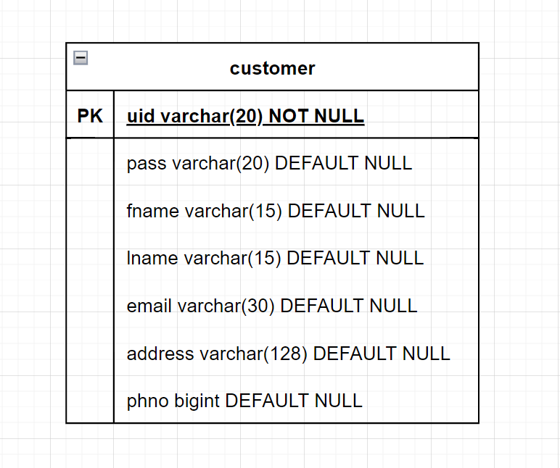

**SELLER:**

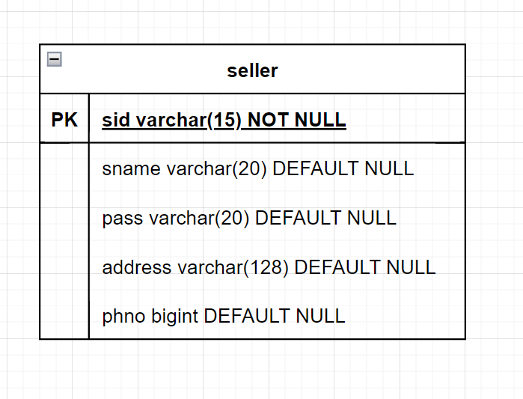

**ORDERS:**

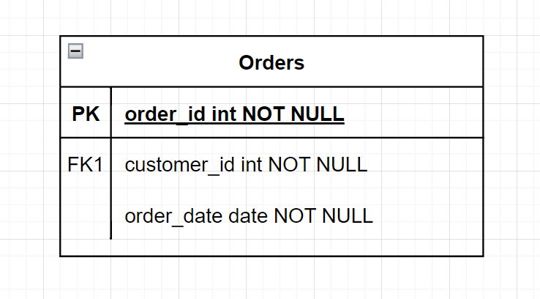

**INVENTORY:**

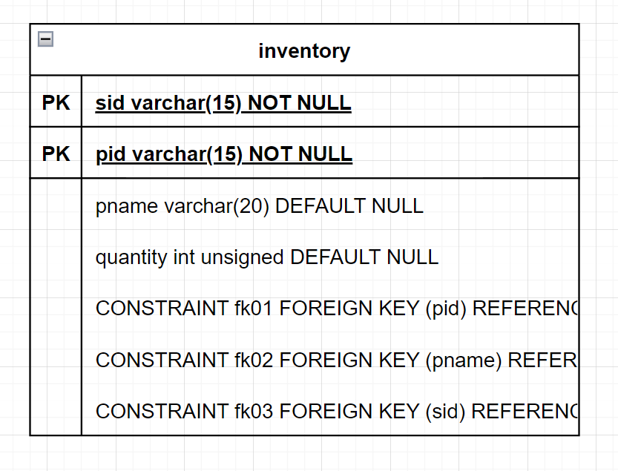

**PRODUCT:**

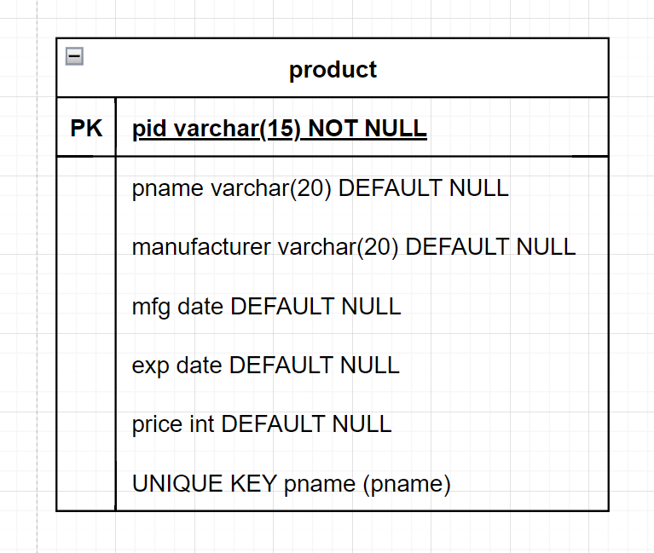

**6. SCREENSHOTS**

**1. :**

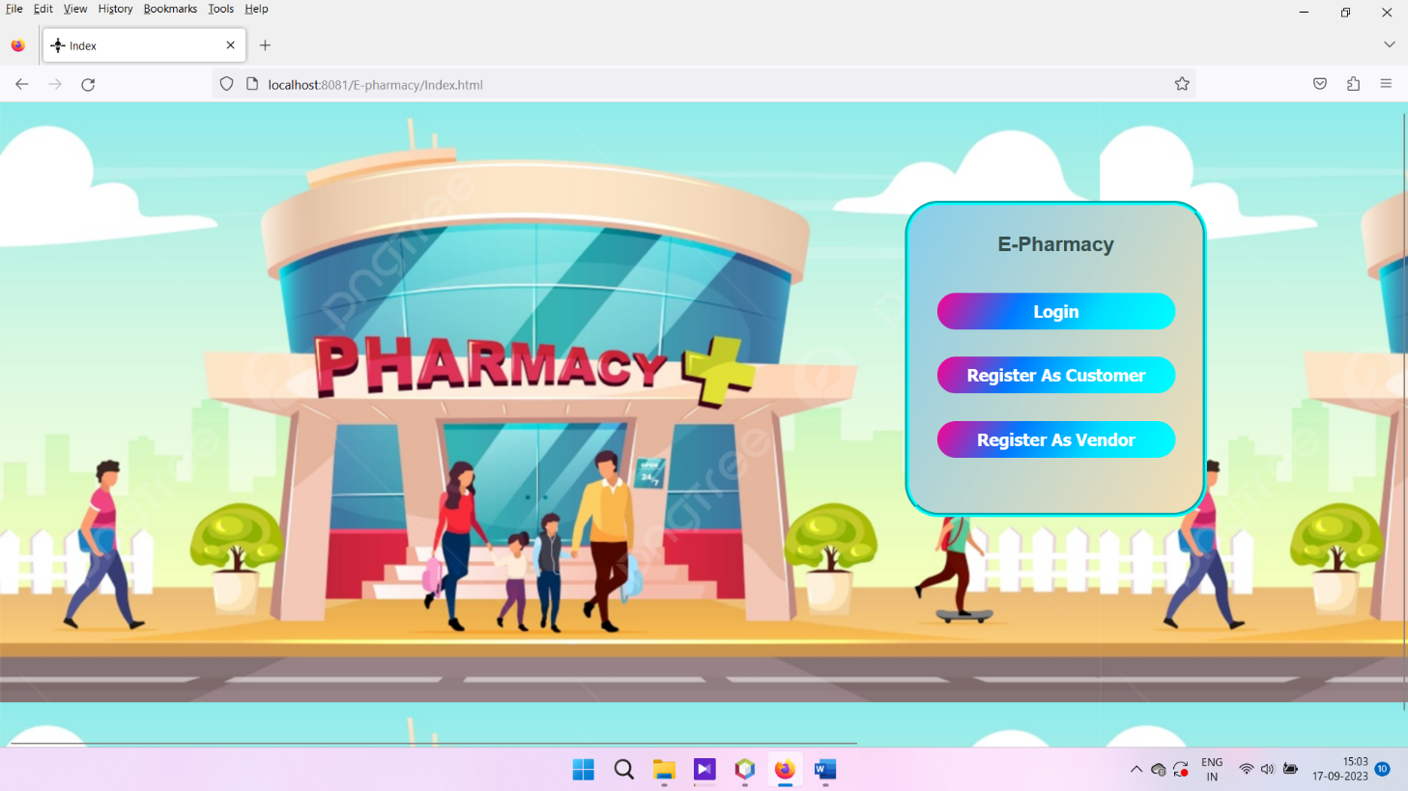

**2. :**

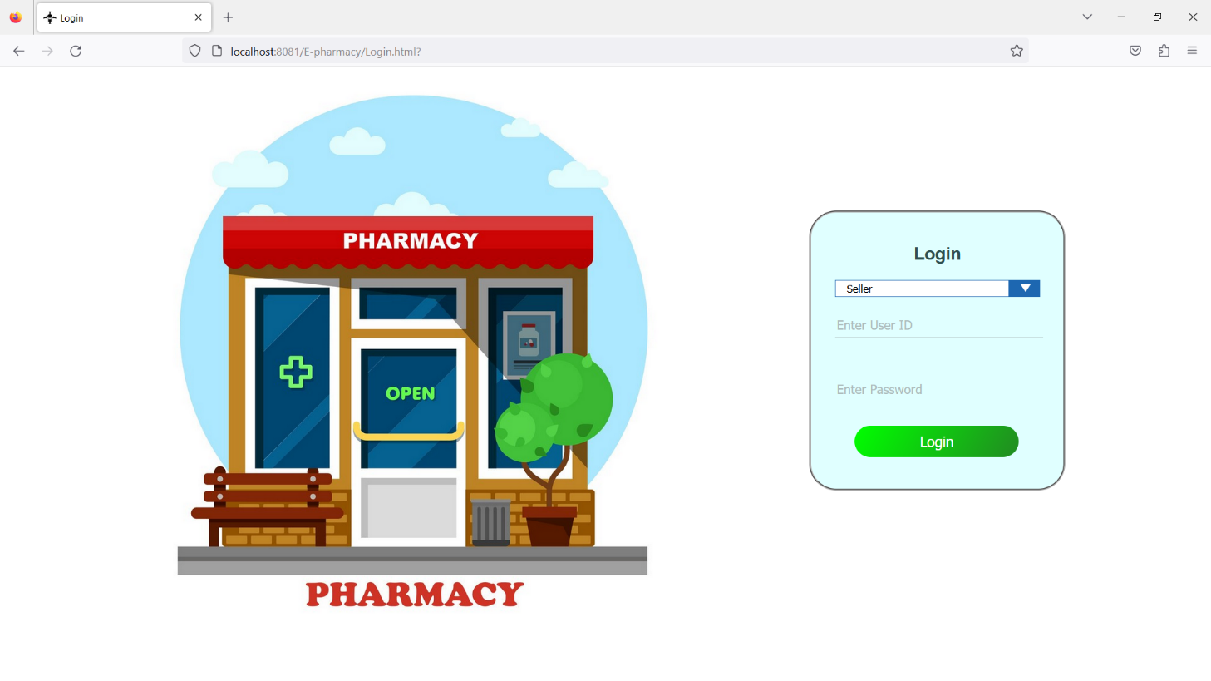

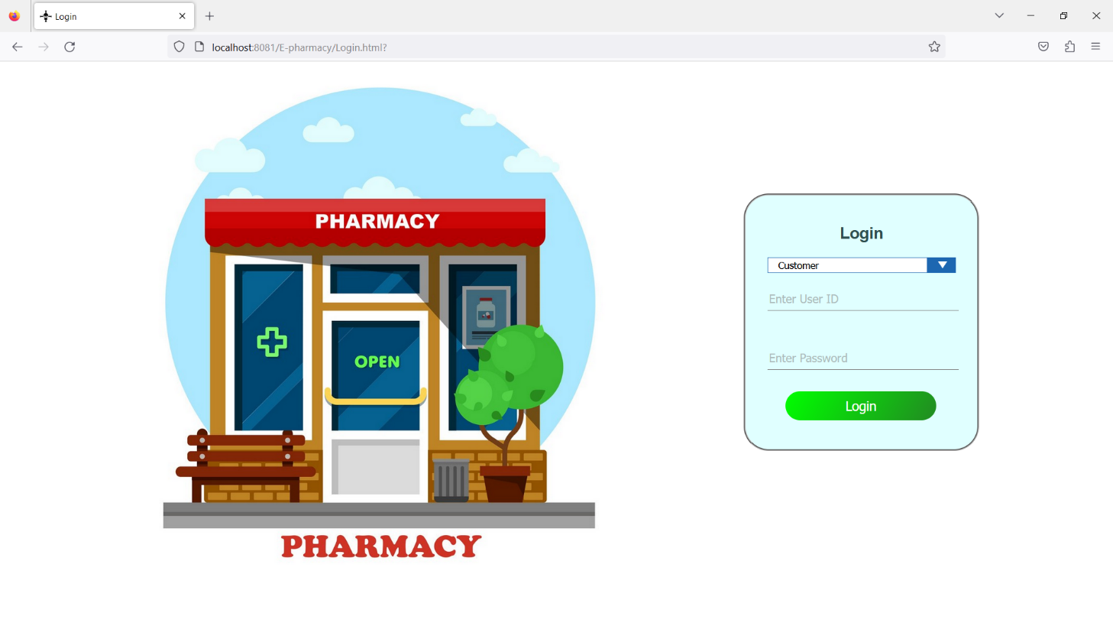

**3.:**

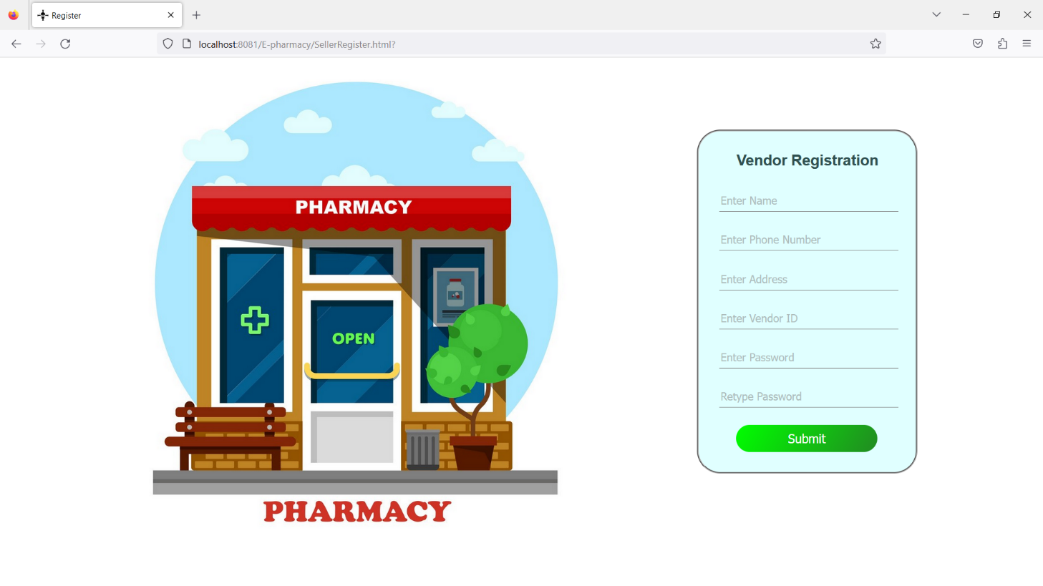

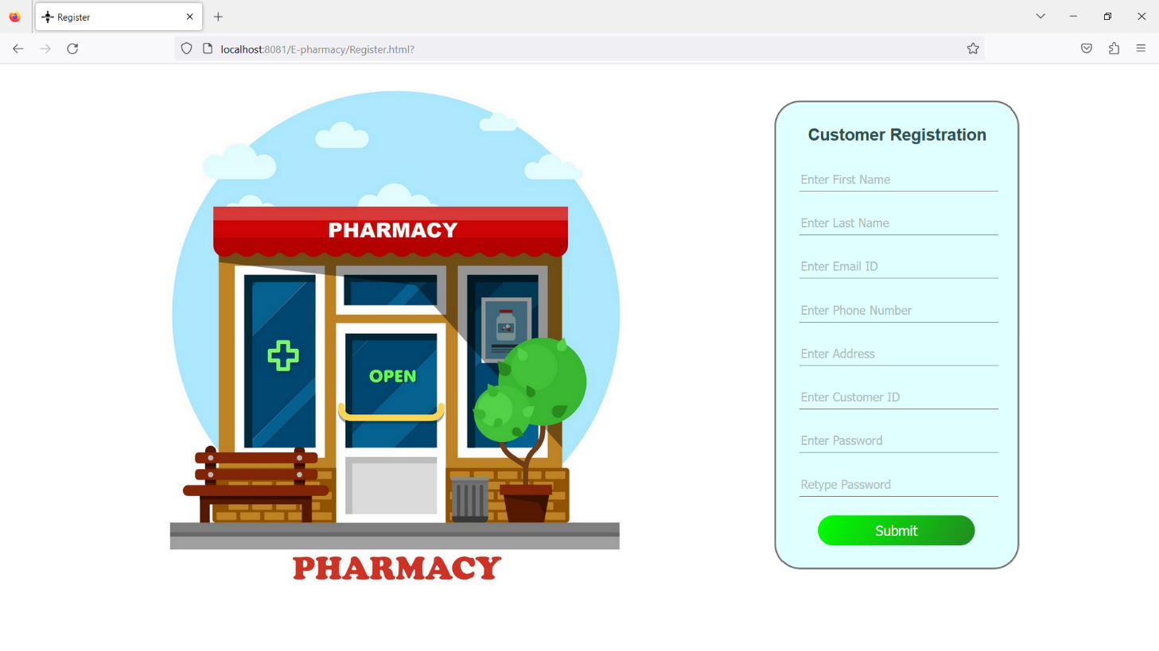

**4.:**

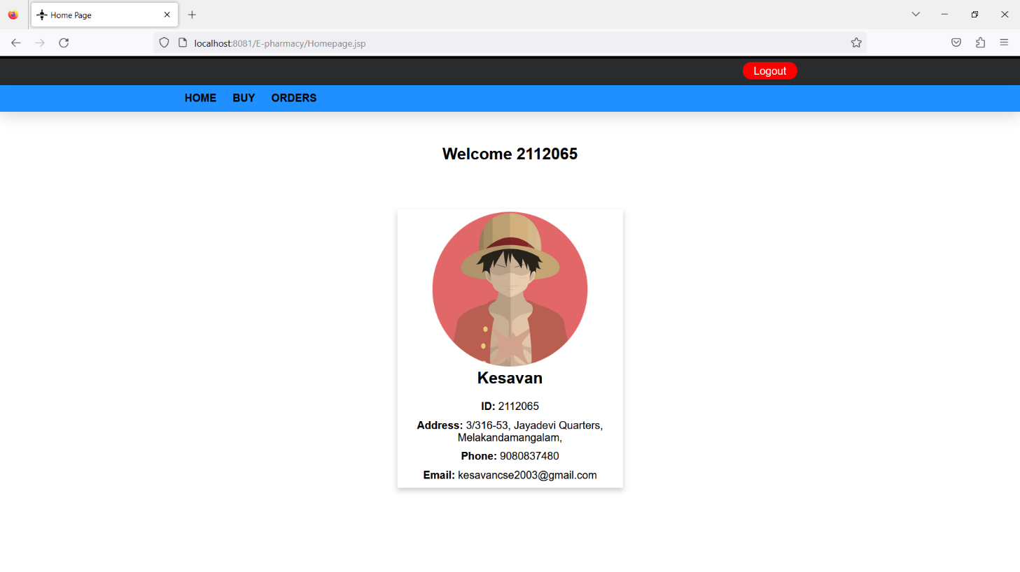

**5.:**

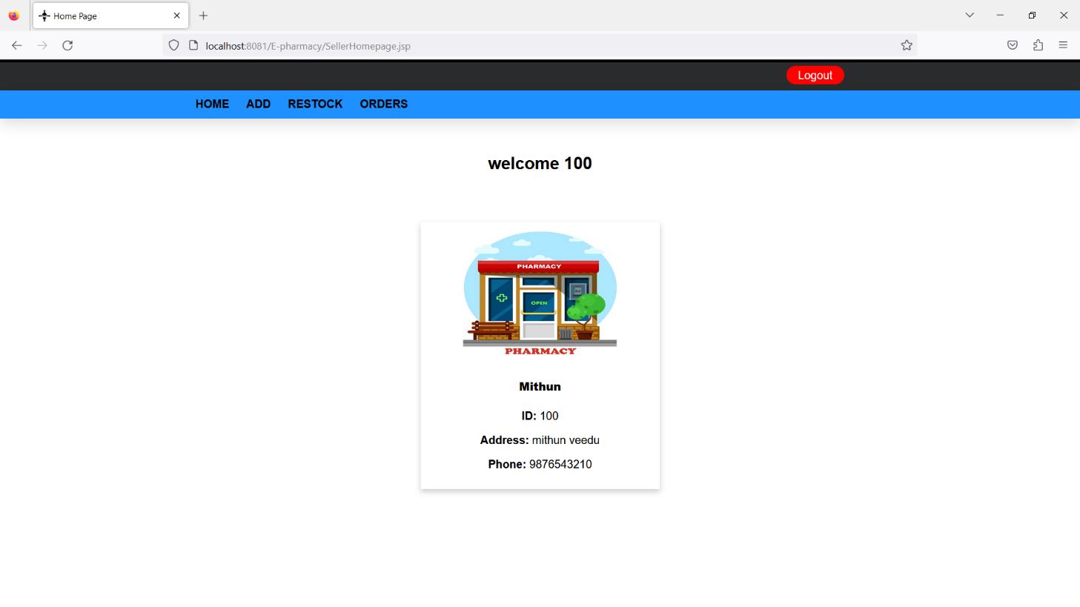

**6.:**

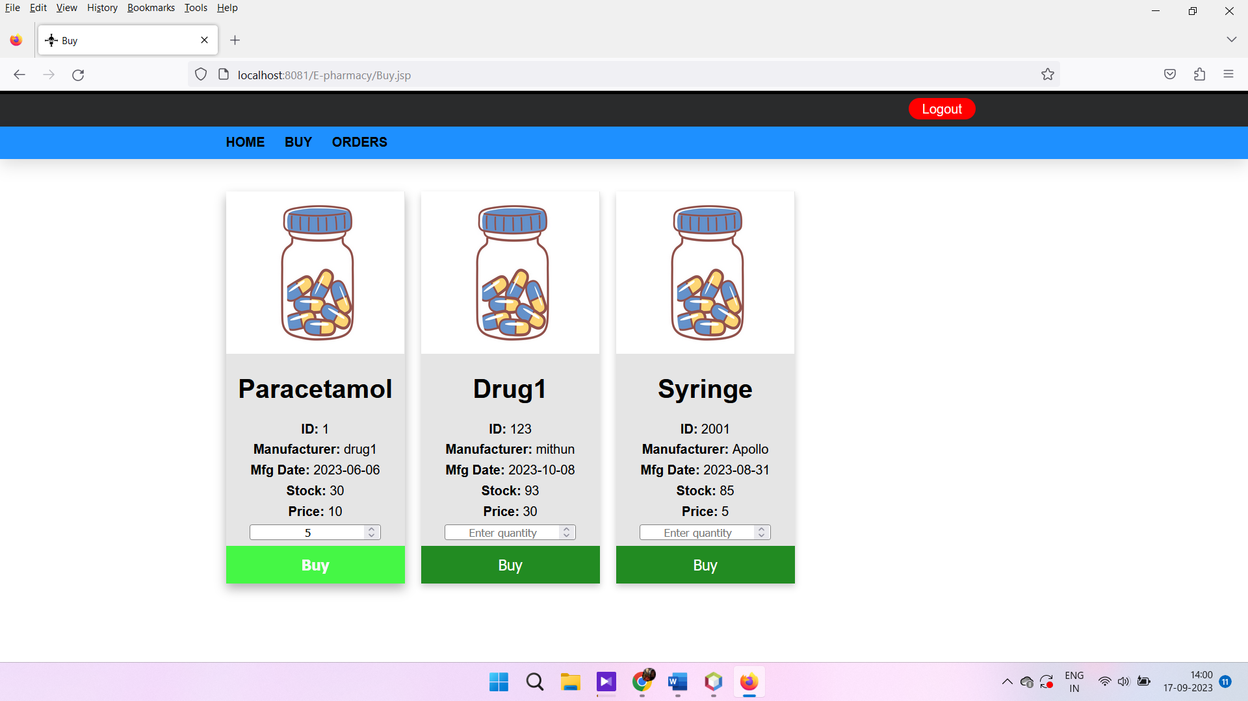

**7.:**

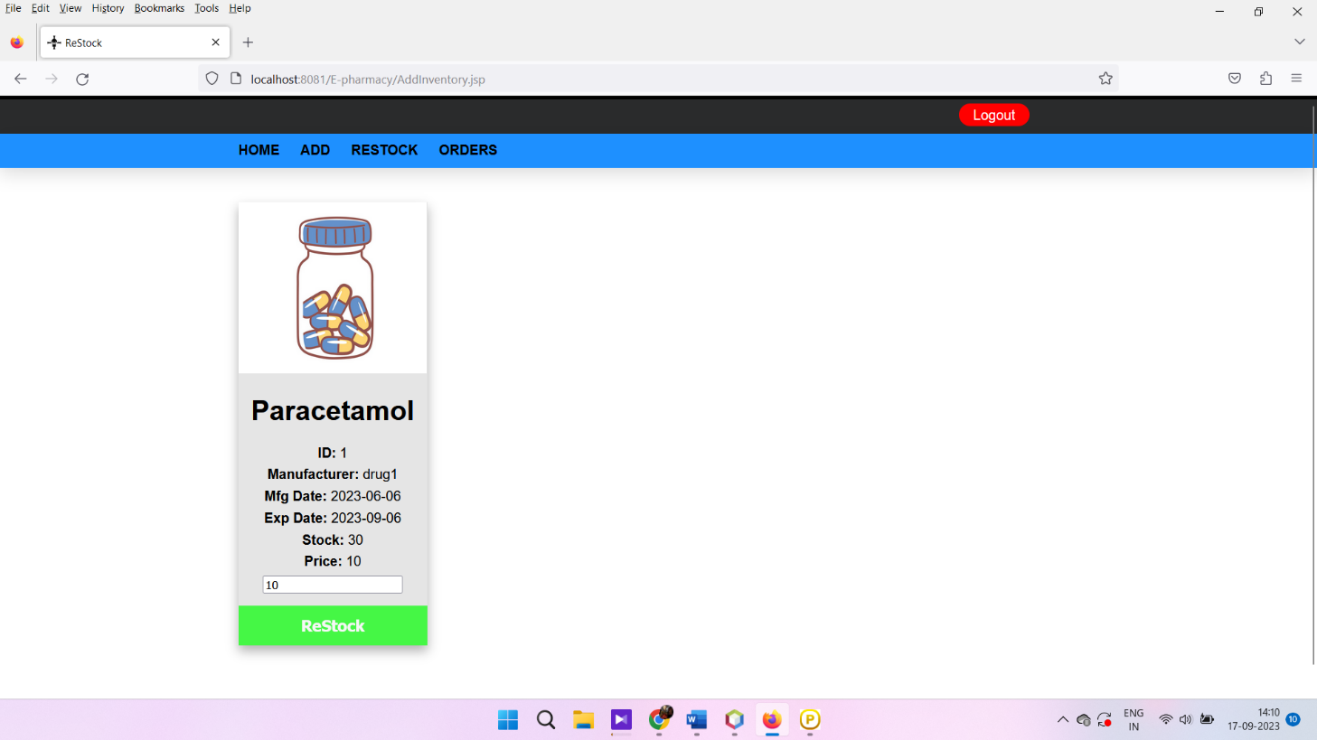

**8.:**

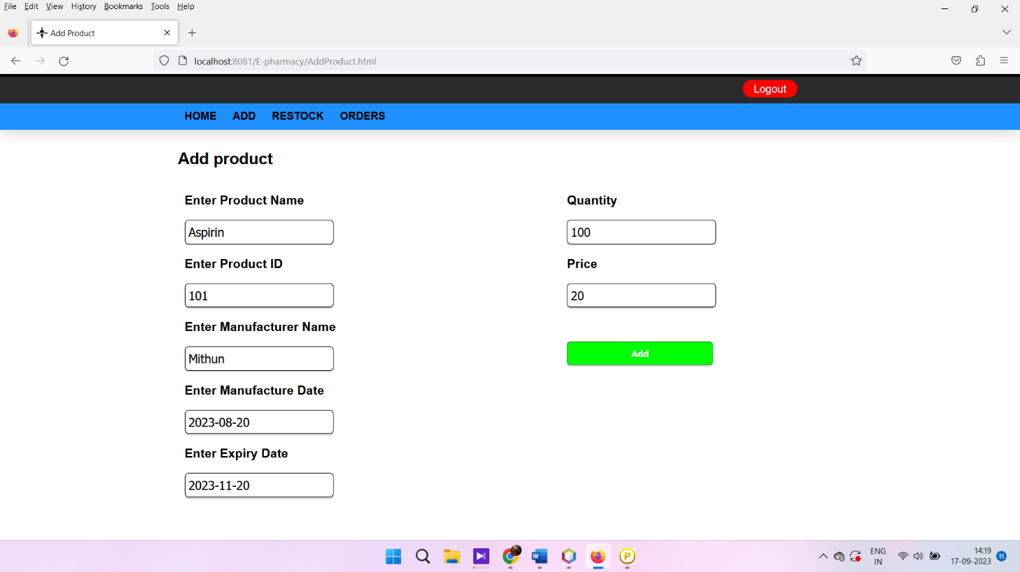

**9.:**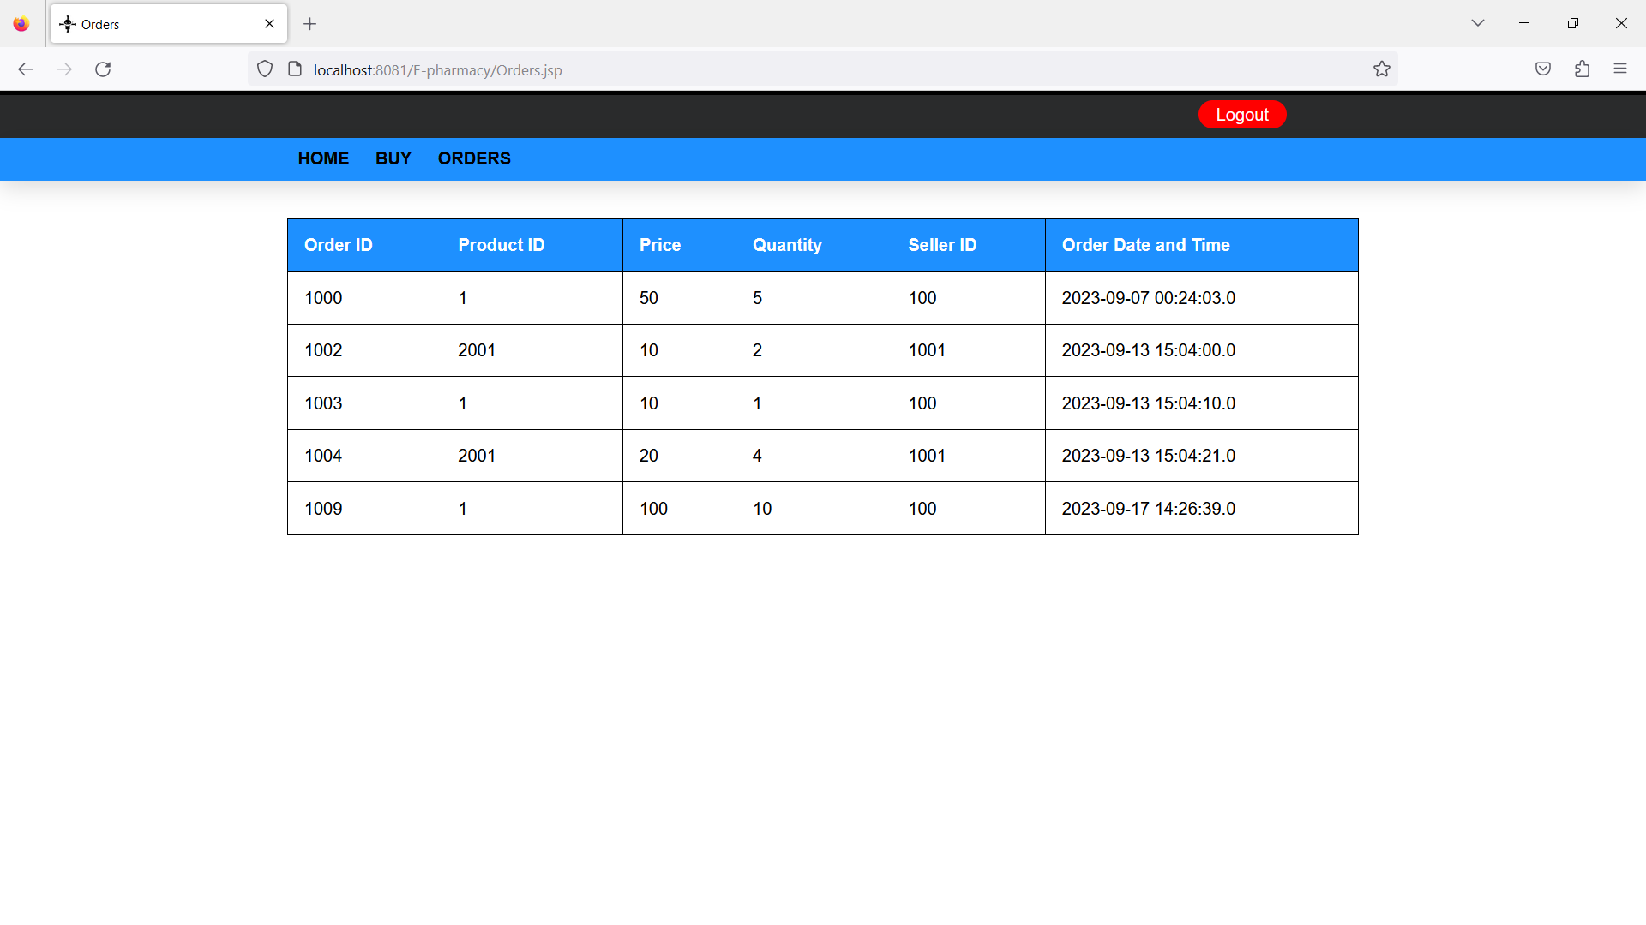

**7. SOURCE CODE**

**Login.jsp :**

<%@ page language="java" contentType="text/html; charset=ISO-8859-1"

pageEncoding="ISO-8859-1"%>

<!DOCTYPE html>

<html>

<head>

<meta charset="ISO-8859-1">

<title>Login</title>

</head>

<body>

<%@ page import="java.sql.*" %>

<%@ page import="javax.sql.*" %>

<%

String uid1=request.getParameter("userid");

String pass1=request.getParameter("password");

String u2=request.getParameter("utype");

int u=Integer.parseInt(u2);

HttpSession httpSession = request.getSession();

httpSession.setAttribute("currentuser", uid1);

ResultSet rs=null;

Connection conn=null;

PreparedStatement ps=null;

String query2="SELECT sid,pass from Seller WHERE sid=?";

String query1="SELECT uid,pass from customer WHERE uid=?";

try{

Class.forName("com.mysql.jdbc.Driver");

conn=DriverManager.getConnection("jdbc:mysql://localhost:3306/drugdatabase","root","Immithun2605@");

if(u==2)

{

ps=conn.prepareStatement(query2);

ps.setString(1,uid1);

}

else if(u==1)

{

ps=conn.prepareStatement(query1);

ps.setString(1,uid1);

}

rs=ps.executeQuery();

if(rs.next())

{

if((rs.getString(2)).equals(pass1))

{

if(u==1)

response.sendRedirect("Homepage.jsp");

else

if(u==2)

response.sendRedirect("SellerHomepage.jsp");

}

else

{

response.sendRedirect("LoginError1.html");

}

}

else

response.sendRedirect("LoginError2.html");

}

catch(Exception e){

out.println(e);

}

finally {

try { if (rs != null) rs.close(); } catch (Exception e) {};

try { if (ps != null) ps.close(); } catch (Exception e) {};

try { if (conn != null) conn.close(); } catch (Exception e) {};

}

%>

</body>

</html>

**Register.jsp :**

<%@ page language="java" contentType="text/html; charset=ISO-8859-1"

pageEncoding="ISO-8859-1"%>

<!DOCTYPE html>

<html>

<head>

<meta charset="ISO-8859-1">

<title>Insert title here</title>

</head>

<body>

<%@ page import="java.sql.*" %>

<%@ page import="javax.sql.*" %>

<%

String fname1=request.getParameter("fname");

String lname1=request.getParameter("lname");

String email1=request.getParameter("email");

String phno1=request.getParameter("phno");

String uid1=request.getParameter("uid");

long phno2=Long.parseLong(phno1);

String address1=request.getParameter("address");

String pass1=request.getParameter("pass1");

String pass2=request.getParameter("pass2");

PreparedStatement ps1=null;

PreparedStatement ps2=null;

Connection conn=null;

ResultSet rs=null;

String query1="SELECT uid from customer WHERE uid=?";

String query2="INSERT INTO customer(uid,pass,fname,lname,email,address,phno) VALUES(?,?,?,?,?,?,?)";

try{

Class.forName("com.mysql.jdbc.Driver");

conn=DriverManager.getConnection("jdbc:mysql://localhost:3306/drugdatabase","root","Immithun2605@");

ps1=conn.prepareStatement(query1);

ps1.setString(1,uid1);

rs=ps1.executeQuery();

if(rs.next())

{

response.sendRedirect("RegisterError1.html");

}

else

{

if(pass1.equals(pass2))

{

ps2=conn.prepareStatement(query2);

ps2.setString(1,uid1);

ps2.setString(2,pass1);

ps2.setString(3,fname1);

ps2.setString(4,lname1);

ps2.setString(5,email1);

ps2.setString(6,address1);

ps2.setLong(7,phno2);

int i=ps2.executeUpdate();

response.sendRedirect("Login.html");

}

else

response.sendRedirect("RegisterError2.html");

}

}

catch(Exception e){

out.println(e);

}

finally{

try { if (rs != null) rs.close(); } catch (Exception e) {};

try { if (ps1 != null) ps1.close(); } catch (Exception e) {};

try { if (ps2 != null) ps2.close(); } catch (Exception e) {};

try { if (conn != null) conn.close(); } catch (Exception e) {};

}

%>

</body>

</html>

**HomePage.jsp:**

<%@ page language="java" contentType="text/html; charset=ISO-8859-1"

pageEncoding="ISO-8859-1"%>

<!DOCTYPE html>

<html>

<head>

<meta charset="ISO-8859-1">

<title>Home Page</title>

<link rel="stylesheet" href="css/Homepage.css">

</head>

<body>

<div class="main">

<div class="topbar1"></div>

<div class="topbar2">

<div class="container1">

<div class="logout-btn">

<a href="Logout.jsp">Logout</a>

</div>

</div>

</div>

<div class="header">

<div class="container2">

<div class="navbar">

<a href="Homepage.jsp">HOME</a>

<a href="Buy.jsp">BUY</a>

<a href="Orders.jsp">ORDERS</a>

</div>

</div>

</div>

</div>

<div class="active">

<%@ page import="java.sql.*" %>

<%@ page import="javax.sql.*" %>

<%

HttpSession httpSession = request.getSession();

String guid=(String)httpSession.getAttribute("currentuser");

%>

<div class="filler"></div>

<h2>Welcome <%=guid%></h2>

<%

ResultSet rs=null;

PreparedStatement ps=null;

java.sql.Connection conn=null;

String query="select fname,uid,address,phno,email from customer where uid=?";

try{

Class.forName("com.mysql.jdbc.Driver");

conn=DriverManager.getConnection("jdbc:mysql://localhost:3306/drugdatabase","root","Immithun2605@");

ps=conn.prepareStatement(query);

ps.setString(1,guid);

rs=ps.executeQuery();

if(rs.next())

{

%>

<div class="filler2"></div>

<div class="card">

<img src="images/User.png" class="Avatar" width=234 height=234>

<div class="container">

<div class="space1"><b><%=rs.getString("fname") %></b></div>

<div class="filler3"></div>

<div class="space"><b>ID: </b><%=rs.getString("uid") %></div>

<div class="space"><b>Address: </b><%=rs.getString("address") %></div>

<div class="space"><b>Phone: </b><%=rs.getString("phno") %></div>

<div class="space"><b>Email: </b><%=rs.getString("email") %></div>

</div>

</div>

<%

}

}

catch(Exception e)

{

out.println("error: "+e);

}

finally {

try { if (rs != null) rs.close(); } catch (Exception e) {};

try { if (ps != null) ps.close(); } catch (Exception e) {};

try { if (conn != null) conn.close(); } catch (Exception e) {};

}

%>

</div>

</body>

</html>

**Orders.jsp :**

<%@ page language="java" contentType="text/html; charset=ISO-8859-1"

pageEncoding="ISO-8859-1"%>

<!DOCTYPE html>

<html>

<head>

<meta charset="ISO-8859-1">

<title>Orders</title>

<link rel="stylesheet" href="css/Orders.css">

</head>

<body>

<div class="main">

<div class="topbar1"></div>

<div class="topbar2">

<div class="container1">

<div class="logout-btn">

<a href="Logout.jsp">Logout</a>

</div>

</div>

</div>

<div class="header">

<div class="container2">

<div class="navbar">

<a href="Homepage.jsp">HOME</a>

<a href="Buy.jsp">BUY</a>

<a href="Orders.jsp">ORDERS</a>

</div>

</div>

</div>

</div>

<div class="active">

<%@ page import="java.sql.*" %>

<%@ page import="javax.sql.*" %>

<%

HttpSession httpSession = request.getSession();

String gid=(String)httpSession.getAttribute("currentuser");

%>

<div class="filler"></div>

<%

int flag=0;

ResultSet rs=null;

CallableStatement cs=null;

java.sql.Connection conn=null;

try{

Class.forName("com.mysql.jdbc.Driver");

conn=DriverManager.getConnection("jdbc:mysql://localhost:3306/drugdatabase","root","Immithun2605@");

cs = conn.prepareCall("call getorders(?)");

cs.setString(1, gid);

rs = cs.executeQuery();

%><div class="filler2"></div>

<table class="tables">

<tr>

<th>Order ID</th>

<th>Product ID</th>

<th>Price</th>

<th>Quantity</th>

<th>Seller ID</th>

<th>Order Date and Time</th>

</tr>

<%while(rs.next())

{

%>

<tr>

<td><%=rs.getInt("oid") %></td>

<td><%=rs.getString("pid") %></td>

<td><%=rs.getInt("price") %></td>

<td><%=rs.getInt("quantity") %></td>

<td><%=rs.getString("sid") %></td>

<td><%=rs.getTimestamp("orderdatetime") %>

</tr>

<%

}

%>

</table>

</div>

<%

}

catch(Exception e)

{

out.println("error: "+e);

}

finally {

try { if (rs != null) rs.close(); } catch (Exception e) {};

try { if (cs != null) cs.close(); } catch (Exception e) {};

try { if (conn != null) conn.close(); } catch (Exception e) {};

}

%>

</body>

</html>

**PlaceOrder.jsp :**

<%@ page language="java" contentType="text/html; charset=ISO-8859-1"

pageEncoding="ISO-8859-1"%>

<!DOCTYPE html>

<html>

<head>

<meta charset="ISO-8859-1">

<title>Orders JSP</title>

</head>

<body>

<%@ page import="java.sql.*" %>

<%@ page import="javax.sql.*" %>

<%

String pid=request.getParameter("pid");

int qr=Integer.parseInt(request.getParameter("orderquantity"));

HttpSession httpSession = request.getSession();

String guid=(String)httpSession.getAttribute("currentuser");

Connection conn=null;

ResultSet rs=null;

PreparedStatement ps=null;

PreparedStatement ps2=null;

String a,b;

int c;

String query1="select P.pid,O.sid,P.price from inventory o,product p where p.pid=? and p.pid=o.pid";

String query2="insert into orders(pid,sid,uid,quantity,price) values(?,?,?,?,?)";

try{

Class.forName("com.mysql.jdbc.Driver");

conn=DriverManager.getConnection("jdbc:mysql://localhost:3306/drugdatabase","root","Immithun2605@");

ps=conn.prepareStatement(query1);

ps.setString(1,pid);

rs=ps.executeQuery();

if(rs.next())

{

a=rs.getString("pid");

b=rs.getString("sid");

c=rs.getInt("price");

ps2=conn.prepareStatement(query2);

ps2.setString(1,a);

ps2.setString(2,b);

ps2.setString(3,guid);

ps2.setInt(4,qr);

ps2.setInt(5,qr*c);

int i=ps2.executeUpdate();

response.sendRedirect("Orders.jsp");

}

}

catch(Exception E)

{

out.println(E);

}

finally {

try { if (rs != null) rs.close(); } catch (Exception e) {};

try { if (ps != null) ps.close(); } catch (Exception e) {};

try { if (ps2 != null) ps2.close(); } catch (Exception e) {};

try { if (conn != null) conn.close(); } catch (Exception e) {};

}

%>

</body>

</html>

**SellerRegister.jsp**

<%@ page language="java" contentType="text/html; charset=ISO-8859-1"

pageEncoding="ISO-8859-1"%>

<!DOCTYPE html>

<html>

<head>

<meta charset="ISO-8859-1">

<title>Register</title>

</head>

<body>

<%@ page import="java.sql.*" %>

<%@ page import="javax.sql.*" %>

<%@ page import="java.lang.*" %>

<%

String name1=request.getParameter("name");

String phno1=request.getParameter("phno");

String uid1=request.getParameter("uid");

long phno2=Long.parseLong(phno1);

String address1=request.getParameter("address");

String pass1=request.getParameter("pass1");

String pass2=request.getParameter("pass2");

PreparedStatement ps1=null;

PreparedStatement ps2=null;

Connection conn=null;

String query1="SELECT sid from seller WHERE sid=?";

String query2="INSERT INTO seller(sid,pass,sname,address,phno) VALUES(?,?,?,?,?)";

ResultSet rs=null;

try{

Class.forName("com.mysql.jdbc.Driver");

conn=DriverManager.getConnection("jdbc:mysql://localhost:3306/drugdatabase","root","Immithun2605@");

ps1=conn.prepareStatement(query1);

ps1.setString(1,uid1);

rs=ps1.executeQuery();

if(rs.next())

{

response.sendRedirect("SellerRegisterError1.html");

}

else

{

if(pass1.equals(pass2))

{

ps2=conn.prepareStatement(query2);

ps2.setString(1,uid1);

ps2.setString(2,pass1);

ps2.setString(3,name1);

ps2.setString(4,address1);

ps2.setLong(5,phno2);

int i=ps2.executeUpdate();

response.sendRedirect("Login.html");

}

else

response.sendRedirect("SellerRegisterError2.html");

}

}

catch(Exception e){

out.println("error: "+e);

}

finally {

try { if (rs != null) rs.close(); } catch (Exception e) {};

try { if (ps1 != null) ps1.close(); } catch (Exception e) {};

try { if (ps2 != null) ps2.close(); } catch (Exception e) {};

try { if (conn != null) conn.close(); } catch (Exception e) {};

}

%>

</body>

</html>

**SellerOrders.jsp :**

<%@ page language="java" contentType="text/html; charset=ISO-8859-1"

pageEncoding="ISO-8859-1"%>

<!DOCTYPE html>

<html>

<head>

<meta charset="ISO-8859-1">

<title>Orders</title>

<link rel="stylesheet" href="css/Orders.css">

</head>

<body>

<div class="main">

<div class="topbar1"></div>

<div class="topbar2">

<div class="container1">

<div class="logout-btn">

<a href="Logout.jsp">Logout</a>

</div>

</div>

</div>

<div class="header">

<div class="container2">

<div class="navbar">

<a href="SellerHomepage.jsp">HOME</a>

<a href="AddProduct.html">ADD</a>

<a href="AddInventory.jsp">RESTOCK</a>

<a href="SellerOrders.jsp">ORDERS</a>

</div>

</div>

</div>

</div>

<div class="active">

<%@ page import="java.sql.*" %>

<%@ page import="javax.sql.*" %>

<%

HttpSession httpSession = request.getSession();

String guid=(String)httpSession.getAttribute("currentuser");

%>

<div class="filler"></div>

<%

int flag=0;

ResultSet rs=null;

CallableStatement cs=null;

java.sql.Connection conn=null;

try{

Class.forName("com.mysql.jdbc.Driver");

conn=DriverManager.getConnection("jdbc:mysql://localhost:3306/drugdatabase","root","Immithun2605@");

cs = conn.prepareCall("call getsellerorders(?)");

cs.setString(1, guid);

rs = cs.executeQuery();

%><div class="filler2"></div>

<table class="tables">

<tr>

<th>Order ID</th>

<th>Product ID</th>

<th>Price</th>

<th>Quantity</th>

<th>CUSTOMER ID</th>

<th>Order Date and Time</th>

</tr>

<%while(rs.next())

{

%>

<tr>

<td><%=rs.getInt("oid") %></td>

<td><%=rs.getString("pid") %></td>

<td><%=rs.getInt("price") %></td>

<td><%=rs.getInt("quantity") %></td>

<td><%=rs.getString("uid") %></td>

<td><%=rs.getTimestamp("orderdatetime") %>

</tr>

<%

}

%>

</table>

</div>

<%

}

catch(Exception e)

{

out.println("error: "+e);

}

finally {

try { if (rs != null) rs.close(); } catch (Exception e) {};

try { if (cs != null) cs.close(); } catch (Exception e) {};

try { if (conn != null) conn.close(); } catch (Exception e) {};

}

%>

</body>

</html>

**8. CONCLUSION**

The development of an Online E-Pharmacy System using JSP and NetBeans presents a significant opportunity to address the modern healthcare needs of convenience, accessibility, and user-friendly access to pharmaceutical products. This project aimed to provide a comprehensive solution that caters to both customers and vendors in the online pharmaceutical market.

Throughout the project, we have outlined key features and functionalities, including user registration and authentication, product catalog management, shopping cart functionality, order processing, payment integration, inventory management, and optional prescription verification. The technology stack included JSP for dynamic web pages, Java for backend logic, MySQL or similar database management for data storage, and HTML, CSS, and JavaScript for frontend development.

The scope was defined to ensure that the project would deliver a robust and user-friendly system while acknowledging certain limitations and constraints. These limitations may include regional regulatory compliance, specific design and branding requirements, and the need for a separate mobile application.

In essence, the Online E-Pharmacy System aims to bridge the gap between traditional brick-and-mortar pharmacies and the convenience of online shopping. It provides a platform for customers to easily access pharmaceutical products, make informed choices, and place secure orders, while also enabling vendors to manage their inventory efficiently.

As this project progresses, it will be crucial to pay close attention to data security and privacy, ensuring compliance with local healthcare regulations and delivering a seamless user experience. Future developments may include enhancements such as mobile apps, integration with third-party services for drug interaction checks, and advanced analytics for both customers and vendors.

Ultimately, the successful implementation of this Online E-Pharmacy System can have a positive impact on public health by improving access to essential medications and healthcare products, making it a valuable addition to the digital healthcare landscape.

**9. REFERENCES**

**[1]** [Online Medicine Shop Project in JSP Mysql | Netbeans](https://www.youtube.com/watch?v=MiDxdMV_nN8&t=1s)

**[2]** [**https://www.geeksforgeeks.org/introduction-to-jdbc/**](https://www.geeksforgeeks.org/introduction-to-jdbc/)

**[3] https://**[**www.w3schools.com**](http://www.w3schools.com/)**/**

**[4] https://www.vectorstock.com/royalty-free-vector/**